CSA1503-Cloud computing and big data analytics
Experiment-3
Name – Ramya S S
Regno – 192421226
Create a simple cloud software application for Car Booking Reservation System using any Cloud Service Provider to demonstrate SaaS include the necessary fields such as search for cabs, from, to, rental, out station, Package type, hours/Days etc.
INPUT
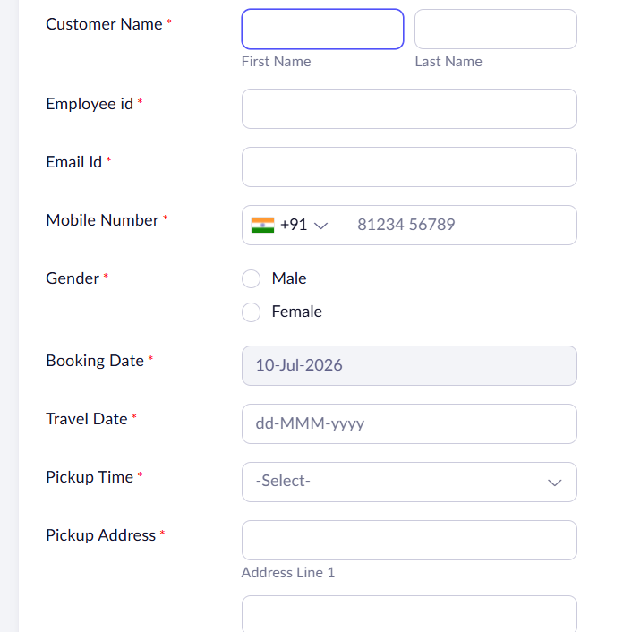
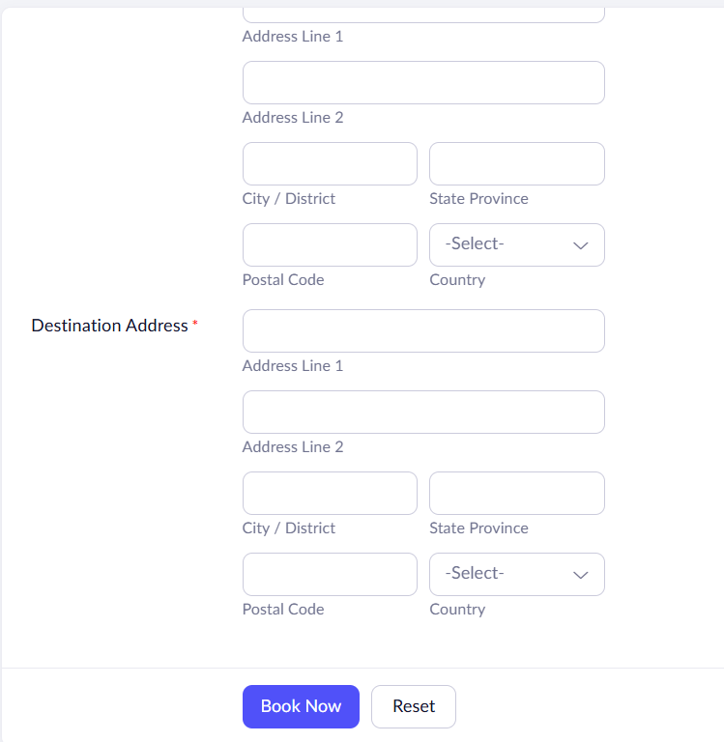
OUTPUT
